**Infant Life Support Simulation**

*rapport*

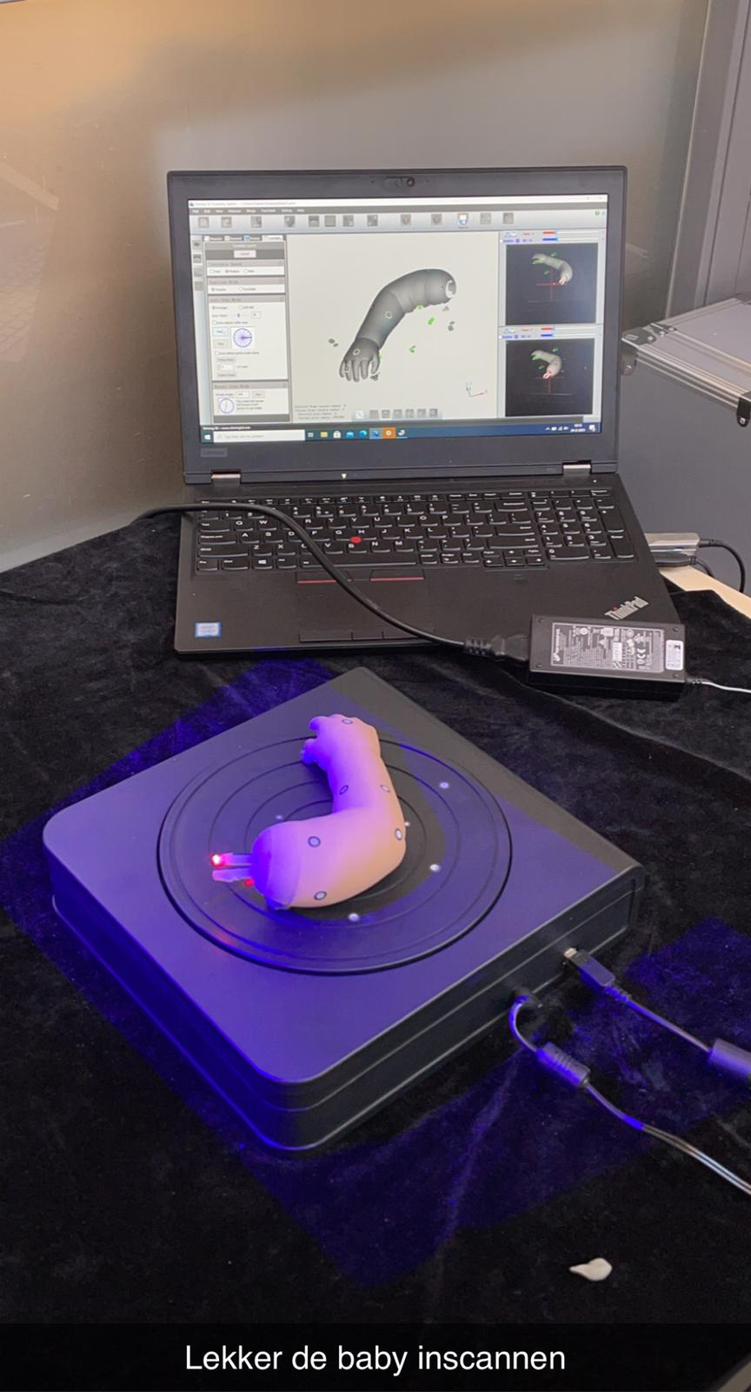

Location: HAN, Ruitenberglaan 26, 6826 CC Arnhem

Client: MSc. Johan Korten, Docent HAN Arnhem

Project owner: MSc. Johan Korten, Docent HAN Arnhem

Project advisors:

**Johan Korten** | Product Owner

**Irene van der Zee** | Industrial Design and Engineering

**Lieke Oving** | Industrial Design and Engineering

**Sterre Wouters**  | Industrial Design and Engineering

**Lars van Zanten** | Industrial Engineering and Management

**Joost van Zanten** | Electrical Engineering Embedded Systems

**Dingzhu Chen** | Electrical Engineering Embedded Systems

**Tharsen Kumar** | Electrical Engineering Industrial Power Systems

**Ramon Jansen** | Electrical Engineering Industrial Power Systems

# preface

# Management Summary

Manager summary, briefly describe the content of this report (non-technically)

Table of contents

preface 2

Management Summary 3

Glossary 5

1. Problem definition 6

2. Scope per course, division of roles, stakeholders and users 6

2.1 Industrial Engineering and Design (IDE) 6

2.2 Industrial Engineering and Management(IEM) 6

2.3 Electrical Engineering Embedded Systems (ESE) 6

2.4 Electrical Engineering Industrial Power Systems (IPS) 6

2.5 Additional stakeholders 7

3. Who are the users? 8

4. Project goals 9

5. Product Backlog 9

6. Sprint 0 introduction and orientation 11

6.1 Testing silicone skin and mold making 11

6.2 Auditive feedback 12

6.3 Neopixel LED lights 12

6.4 Power Control and Wireless Charging 12

6.5 marketing context 12

6.6 stakeholders 14

Bibliografie 17

10 rules and contract 17

Attachments 17

Attachment 1 17

Attachment 2 17

Attachment 3 19

Bibliografie 20

# Glossary

|  |  |
| --- | --- |
|  |  |
|  |  |
|  |  |
|  |  |
|  |  |

|  |  |  |  |
| --- | --- | --- | --- |
| Name | Role | e-Mail | Phone |
| Johan Korten | Product Owner | [Johan.Korten@han.nl](mailto:Johan.Korten@han.nl) |  |
| Ramon Jansen | ELT-IPS | [Rw.jansen2@student.han.nl](mailto:Rw.jansen2@student.han.nl) |  |
| Tharsen Kumar | ELT-IPS | [T.Kumar@student.han.nl](mailto:T.Kumar@student.han.nl) | 0687735440 |
| Dingzhu Chen | ELT-ESE | [D.Chen1@student.han.nl](mailto:D.Chen1@student.han.nl) | 0647022950 |
| Irene van der Zee | IPO | [IS.vanderZee@student.han.nl](mailto:IS.vanderZee@student.han.nl) |  |
| Joost van Andel | ELT-ESE | [J.vanAndel@student.han.nl](mailto:J.vanAndel@student.han.nl) | 0610261060 |
| Lars van Zanten | IE&M | [L.vanZanten2@student.han.nl](mailto:L.vanZanten2@student.han.nl) | 0651453002 |
| Lieke Oving | IPO | [LJ.Oving@student.han.nl](mailto:LJ.Oving@student.han.nl) | 0610838268 |
| Sterre Wouters | IPO | [S.Wouters@student.han.nl](mailto:S.Wouters@student.han.nl) | 0634663772 |

# Problem definition

The problem is that the infant life support simulation needs more additional research to fully get working and meets the users demands. These are documented in the Master Thesis: Towards a Modular and Open Patient Simulator written by Mr. Korten.

# Scope per course, division of roles, stakeholders and users

## 2.1 Industrial Engineering and Design (IDE)

In order to help the medical students better understand what to do in a real-life situation the industrial engineering and design students will focus on the realism of the patient simulator. As to achieve to make a real-life patient simulator they will have to do research about the physical aspects such as hair and nails, as well as to the feedback the patient simulator will give, such as colour changes and spit up.

## 2.2 Industrial Engineering and Management(IEM)

The only Industrial Engineering and Management student will look at the business side of the infant life support simulation project. This includes making a Marketing plan, stakeholders' analysis and financial plan. Beside the business side of the project the role of scrum master is for the student at the start of each sprint the IEM student will pick tasks from the backlog.

## 2.3 Electrical Engineering Embedded Systems (ESE)

As Embedded Systems Engineers It will be our task to make sure all small electronics and their programming meet the requirements. We will focus on the electronic parts that handle the inputs from the sensors and the output through actuators. We specialize in the programming behind these parts and will work closely together with IPS to realise the hardware side.

## 2.4 Electrical Engineering Industrial Power Systems (IPS)

Industrial Power Systems is mainly focused on designing and implementing the following type of systems:

* Power conversion (PV, windturbine, SMPS)
* Control system
* Power transmission
* Automation
* Electromechanical systems
* PCB Design (conform EMC guidelines)

The power conversion, control systems, electromechanical systems, automation and PCB Design will be important parts of this project. IPS has to work closely together with ESE to make sure that modulair, compatible and future proof design of the systems are established.

IPS/ESE need to be working closely with IDE and IEM as well. Especially since IDE determines what is considered as the wanted User Experience by the stakeholders and IEM makes sure that there will be looked at business side of the Infant Life Support Simulation project.

IPS/ESE has to make sure that the electronics side of the User Experience determined in collaboration with all disciplines will be translated into a feasible electrical system.

The following systems are going to be either designed or revised:

-NTB

## 2.5 Additional stakeholders

|  |  |  |  |  |
| --- | --- | --- | --- | --- |
| **Stake**  **holder** | **Study** | **Category** | **E-mail** | **importance** |
| Fieke Scholten | IDE | Expert IDE | Fieke.Schulten@han.nl | Manage closely |
| Paul van Wegen | All | Skills docent | Paul.vanWegen@han.nl | Keep informed |
| Nanda Verheul | All | IC nurse |  | Keep informed |
| Johan Korten | All |  | Johan.Korten@han.nl | Manage closely |
| Nicolette Post | All |  | [Nicolette.Post@han.nl](mailto:Nicolette.Post@han.nl) | Keep Informed |
| Tim Antonius | All | Neonate nurse |  |  |
| Theo Peeters | All | Specialist nurse |  |  |
| Tino de Raad | All | CPR trainer at a child hospital |  |  |
| Daniel Vijlbrief | All | Neonatologist |  |  |
| Maarten | All | Master student (specialized in lungs) |  |  |
| Vivian van Tilborg | All | Childrens nurse |  | Keep informed |
| Ambu | IEM | Supplier |  |  |
| CAE | IEM | Supplier | https://caehealthcare.com/patientsimulation |  |
| Gaumard | IEM | Supplier | http://www.gaumard.com/s3201-advanced-multipurpose-patient-simulator |  |
| Laerdal | IEM | Supplier | http://www.laerdal.com/us/ |  |
| Andries van Stralen | IEM | Docent | WA.vanstralen@han.nl | Keep satisfied |
| Katja de Grijff | IEM | docent | [Katja.deGrijff@han.nl](mailto:Katja.deGrijff@han.nl) | Keep satisfied |
| Marius | IEM | Supplier | [marius@skills-meducation.nl](mailto:marius@skills-meducation.nl) | monitor |
| Ramon Jansen | All | Student | [**rw.jansen2@student.han.nl**](mailto:rw.jansen2@student.han.nl) | Manage closely |
| Tharsen Kumar | All | Student | [**t.kumar@student.han.nl**](mailto:t.kumar@student.han.nl) | Manage closely |
| Sterre Wouters | All | Student | [**s.wouters@student.han.nl**](mailto:s.wouters@student.han.nl) | Manage closely |
| Lieke Oving | All | Student | [**lj.oving@student.han.nl**](mailto:lj.oving@student.han.nl) | Manage closely |
| Dingzhu Chen | All | Student | [**d.chen1@student.han.nl**](mailto:d.chen1@student.han.nl) | Manage closely |
| Irene van der Zee | All | Student | [**is.vanderzee@student.han.nl**](mailto:is.vanderzee@student.han.nl) | Manage closely |
| Joost van Andel | all | Student | [**j.vanandel@student.han.nl**](mailto:j.vanandel@student.han.nl) | Manage closely |

**Category**

* **Keep satisfied:** here is the influence high but the interest low
* **Monitor:** here is the influence and interest low
* **Manage closely:** here is the influence and interest high
* **Keep informed:** here is the influence low but the interest high

# 3. Who are the users?

After reading the thesis from Johan and speaking with two stakeholders from the HAN there is a general idea of who the users are. The nurses we spoke with were very clear that they really wanted to use the infant life support simulation. So the HAN and other universities who teach some kind of nursing. We want to expand the scope of users because they are also potential buyers, so we include everyone who works with baby’s and are responsible for their care. The supplier are also users because they can help produce the infant life support simulation.

# 4. Project goals

The project group has as goal to Help Johan improve his current infant simulation. By implementing realistic interaction and real-time auditive and visual feedback. With a business view implemented on the project, this all before 7th of July.

While this also learning from each other and improving our skills working in a project with a big team. In attachment 1 we listed roles and skills we possess but at the same time we can learn from each other

# 5. Product Backlog

|  |  |  |  |  |  |
| --- | --- | --- | --- | --- | --- |
| Nr. | Description | Priority | Category | time | status |
| 1 | Implement speakers for auditive feedback (crying, moaning) | 1 | ESE/IPS/IDE | 2 weeks |  |
| 2 | Implement a way of showing skin discolouration (periphery cyanoses, blushing) | 1 | ESE/IPS/IDE | 4 weeks |  |
| 3 | Implement heartbeat feedback to the user in groin, ankles and wrists | 3 | ESE/IPS/IDE | 3 weeks |  |
| 4 | Improve feedback given through the phone app | 4 | ESE | 2 weeks |  |
| 5 | Improve Touch Sensing Electronics/software including capillary refill | 2 | ESE/IPS/IDE | 2 weeks |  |
| 6 | Improve measuring of chest compression depth | 2 | ESE | 2 weeks |  |
| 7 | Improve detection of movement between head and body | 1 | ESE/IPS | 3 weeks |  |
| 8 | Improve measuring of air movement in the lungs | 3 | ESE/IPS | 2 weeks |  |
| 9 | Improve automation of lung inflation | 1 | ESE/IPS | 2 weeks |  |
| 10 | Improve Bluetooth communication with the phone | 3 | ESE | 1 week |  |
| 11 | Improve logging of feedback results with Raspberry over WIFI | 2 | ESE | 2 weeks |  |
| 12 | Improve data communication between sensor modules | 4 | ESE | 1 week |  |
| 13 | Redesign of the power control board. *Note: It might be possible to design one Power supply which can be used in multiple systems. This could mean; two sprints in one See backlog nr. 43* | 1 | IPS/ESE | 3 weeks |  |
| 14 | Implementing/design of battery system (battery+BMS). | 1 | IPS | 2 weeks |  |
| 15 | Implementing body temperature features in the infant simulator. | 2 | IPS/ESE/IDE | 2 weeks |  |
| 16 | Improve the communication between MCU and Raspberry Pi | 3 | ESE | 1 week |  |
| 17 | Implementing Improvement /design of wireless charging system for the infant | 1 | IPS/ESE | 2 weeks |  |
| 18 | Implementing of moving nostril | 3 | IPS/ESE/IDE | 3 weeks |  |
| 19 | Making it possible to tube the baby | 3 | IPS/ESE/IDE | 2 weeks |  |
| 20 | Discoloration (LED’s) in the cheeks, hand, feet and lips and mouth region. | 1 | IDE/ESE/IPS | 2 weeks |  |
| 21 | A piece of umbilical cord attached to the belly | 3 | IDE | 1 week |  |
| 22 | Create a fully removable outer layer of skin made out of silicones | 1 | IDE |  |  |
| 23 | Removable limbs for easy access and different positions of limbs to simulate different stages health | 1 | IDE | 3 weeks |  |
| 24 | Functional audio feedback to simulate a difficult moan during breathing | 3 | IDE/ ESE/ IPS | 1 week |  |
| 25 | Simulate spit up when there is too much air in the stomach | 4 | IDE/IPS/ESE | 3 weeks |  |
| 26 | Making it possible to place a catheter. | 3 | IDE/IPS | 1 week |  |
| 27 | Making it possible to inflate lungs independently | 1 | IPS/ESE |  |  |
| 28 | map all the stakeholders | 1 | TBK/ all | 1 week |  |
| 29 | Making stakeholders analysis | 1 | IEM | 3 days |  |
| 30 | Making stakeholders matrix | 1 | IEM | 2 days |  |
| 31 | Doing an external analysis for the project( macro) | 3 | IEM | 3 days |  |
| 32 | Doing an external analysis for the project( meso) | 1 | IEM | 3 days |  |
| 33 | Doing an internal analysis for the project( micro, strategic) | 3 | IEM | 3 days |  |
| 34 | Making marketing context | 2 | IEM | 2 weeks |  |
| 35 | Marketing plan | 1 | IEM | 2 weeks |  |
| 36 | Financial situation context | 1 | IEM | 2 weeks |  |
| 37 | Financial report | 2 | IEM | 2 weeks |  |
| 38 | Statistical report of the financial status of the project | 2 | IEM | 2 weeks |  |
| 39 | Improve the interface of the app | 1 | IDE | 4 weeks |  |
| 40 | Researching the user | 1 | IDE | 2 weeks |  |
| 41 | Sensor that confirms a correct positioned thermal probe. (Rectum) | 2 | IDE/IPS/ESE | 4 days |  |
| 42 | Wireless connection between monitoring box and infant simulator | 4 | ESE | 1 week |  |
| 43 | Power supply for monitoring box. *Note: It might be possible to design one Power supply which can be used in multiple systems. This could mean: two sprints in one. See backlog nr. 13* | 1 | IPS | 2 weeks |  |
| 44 | look into motion sensors and which one is the best for the infant life support simulation. |  | IPS/ESE | 3 weeks |  |
| 45 | Motion feedback with RGB lights |  | IPS/ESE | 3 weeks |  |
| 46 | business plan | 2 | IEM | 3 weeks |  |

**Diagram**

* **1** Priority high: high value to do for Johan and interesting to learn.
* **2** Priority medium: had value to the project but mostly interesting to learn.
* **3** Priority low: no value now or its to big, can be interesting to learn.
* **4** Priority very low: no value and no learning interest.

# 6. Sprint 0 introduction and orientation

The chapter describes how the different sprints were divided to achieve the goal. The content of each sprint was decided based on the priorities of the tasks in the backlog. The chapters are divided into their respective analysis, their tests and the conclusion.

## 6.1 Testing silicone skin and mold making

1. Sprint 0 has started off with scanning the arm of the current Life Patient. This all went a bit less smoothly than previously thought. There were a number of problems with the laptop and the object being difficult to scan for the laser. The entire arm was too difficult to scan all at once, so two scans were made of the top and bottom. It took 2 days for the arm to be scanned.
2. When this was done successfully, the scans were aligned in Meshmixer and adjusted to be printed with the 3D printer. With this print a good basis has been set up to then make a mold.
3. Then the formwork was made using the MakerCase program. This formwork is made from an acrylic sheet that was cut with the laser cutter. This was easily put together by means of finger joint and glue. After this the edges were sealed so the tray would not leak.
4. As a small test, a mold was made of the baby's hand. This showed how it worked, how it would feel and the thickness of the silicone.
5. After this, different skin swatches were made from different types of silicone. By giving these silicone swatches a pigment, it was possible to determine which type of silicone was most desired. From this, one type of silicone has been chosen.
6. After a choice was made which silicone to use, it was tested with the pigment and fibers (flocking). The light transmission by means of RGB LEDs and the thickness of the swatches were examined. It is now clear which silicone, color and fibers are suitable. This can now be used for casting the arm.

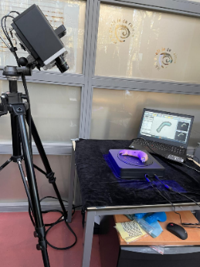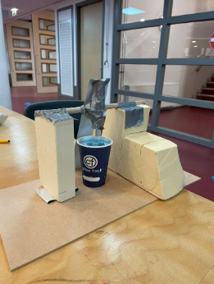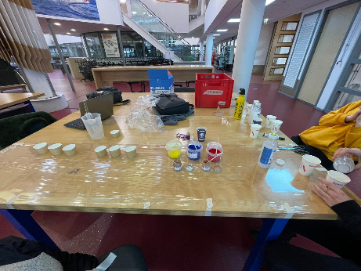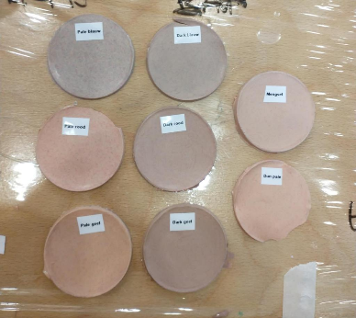

## 6.2 Auditive feedback

**Speaker**

There are two speaker types we can take into consideration. This is the conventional electromagnetic loudspeaker (AKA dynamic loudspeaker) and the electrostatic loudspeaker. These two differ in the way they create sound. Both of them have advantages and disadvantages. The main difference in the resulting sound is the frequency response. Electrostatic loudspeakers are very good at creating higher pitched noises but fall off at the lower frequencies. And electromagnetic loudspeakers are better all-rounders. In our case, most, if not all, of the audio samples will have a medium to high frequency which means both would suffice. Electrostatic loudspeakers have extremely light weight diaphragms when compared to electromagnetic loudspeakers. This means that the casing of the speaker will vibrate much less which is beneficial for us because we don’t want the baby to start vibrating when it’s producing sound. Electromagnetic speakers also manage a much clearer sound more easily because of the very minimal resonance. In our case the electrostatic speaker only has advantages which is the reason why we have decided to use them in the baby.

The speaker we use is the one from the Adafruit STEMMA speaker board. This is a small board with a electrostatic speaker and an amplifier built in. It takes an analogue input in the shape of a waveform audio file and plays it on the speaker. To control it we use a feather M0 board. This board has a DAC built in which we can use to send the audio to the board. This board is excellent for our prototyping purposes because we don’t have to worry about using a separate amplifier board. The audio quality isn’t to great but it’s sufficient for testing. We use an SD card slotted in the feather M0 SD card reader which allows us to easily test our audio samples and has enough storage space to hold a lot of samples. It would however be a hassle to put new audio samples on it when the baby is in a more complete form. The alternative would be to use an I2S connection to transmit the audio file data between components. This would result in additional loads on other components but could give us the flexibility to for example stream the audio from a mobile device which would be handy if we quickly wanted to try new samples and the module itself would then not have to be accessed anymore. This would be more work but could be a nice feature that we can make in the future if we decide it is needed.

**Sound samples**

A baby can make a lot of different sounds which can mean a lot of different things. Not all sounds are relevant to us though, only the sounds that have significant meaning during CPR need to be simulated. An important indication that the baby is still responsive is the sound that it makes. Generally speaking, when the baby is crying it is responsive. Another indicator of responsiveness is if you can hear the baby breathing normally, and coughing might occur when the baby regains responsiveness. One of the important noises that indicate something is wrong is that of a stridor. A stridor means that the airway of the baby is partially blocked which results in a noisy or high-pitched sound whilst breathing.

Because we are still prototyping, we are not worried about the realism of the sounds yet. Instead, we've just made sure there is at least one of every relevant type of sound the baby can make. This will allow us to fill in every use case with these temporary samples. In the future, these samples can be replaced by more realistic ones or there can be more varieties of the same type of sound to make it sound less like it's looping the same sample and therefore less robotic. We are currently limited by the hardware to use only mono unsigned 8-bit WAV files at 44.1 kHz sample rate which means that in order to get more realistic sound we would need better hardware as well.

## 6.3 Neopixel LED lights

The Neopixel LED's communicate with the SAMD processor through an “SPI like protocol”. They require a data and clock signal. The SAMD sends information about the colour of the LED to the Neopixel. In case of a strip with multiple Neopixels it also requires information saying which pixel gets which colour.

For testing the Neopixel we made a setup using several potentiometers that change the colour and brightness of the Neopixel. There are 4 potentiometers which get read through 4 analogue inputs on the board. Three for the RGB value and one for the overall brightness. The values of the first three get scaled down from 0 – 4095(which is the analogue input value) to 0 – 255(which is the red green or blue value), and the brightness value gets scaled down to 0 – 100. The Neopixel library has the functionality to automatically apply a brightness value but because we want to know the actual RGB value we sent to the Neopixel we calculate the dimmed down colour ourselves. To calculate the final RGB value we take the R, G and B values obtained from the potentiometers and scale them down according to the brightness value with the following formula.

(brightness / 100) * [colour value] = [new colour value], which gets applied to the red green and blue values. The RGB value that gets transmitted to the Neopixel also gets printed to the serial output so we can document the used colour.

After testing three kinds of LEDs, the conclusion is that WS2812B is a suitable LED for the infant life simulator. It is because it shows powerful brightness, and it is easy to control colors in the program. For more information of LEDs testing, see “rapportage LED”.docx (stored in: Infant Life Support Simulation>ELT>ELT-IPS)

## 6.4 Power Control and Wireless Charging

### Powercontroller

**The Current Power Supply**

The current power supply is insufficient due to the following elements:

- Temperature issues (the power control board gets too hot)

- EMC issues

These issues are based on information provided by the PO. No tests have been performed by this group to verify the above stated issues.

**Power Supply Requirements**

The battery and it’s BMS are part of the Power Supply System.

The requirements are as follows:

* The battery needs to be at least 34Wh. This is based on the power consumption of the system and it’s peripherals and on the fact that the battery needs to last at least one training cycle and exam (4 hours total).
* Wireless charging must be possible
* Total peak power of 50W
* Communication with the powerboard is necessary (to share the remaining battery voltage etc).
* 5V (max 4A) and 12V (max 2.5A) output power connection. Power is converted locally if 3.3V is needed.
* Charging through DC power supply must be possible.
* Qi protocol is should be used for wireless charging.

**Power Supply System Architecture**

Shown in figure X is the proposal of the System Architecture of the power supply.

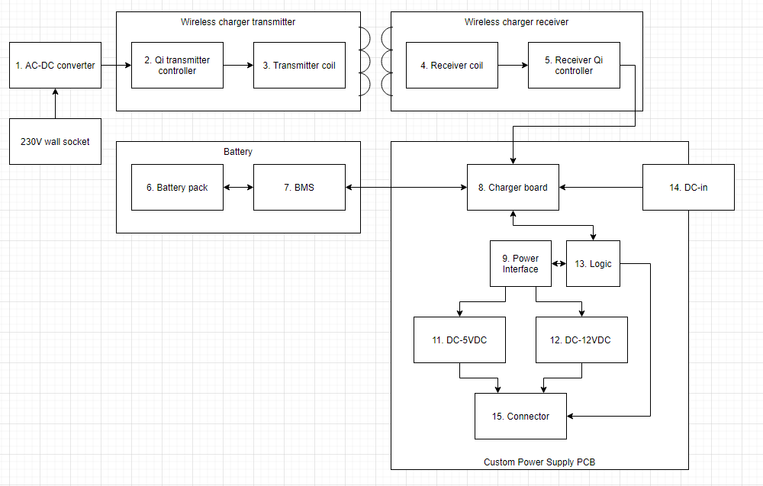

From this figure can be derived that one new PCB should be designed. The BMS should preferably be an off the shelf part.

### Wireless charging

**Field research**

Measurements on the current wireless charging system are performed. The temperature was measured while a 5 Ohm load was connected so a current of 1A would flow.

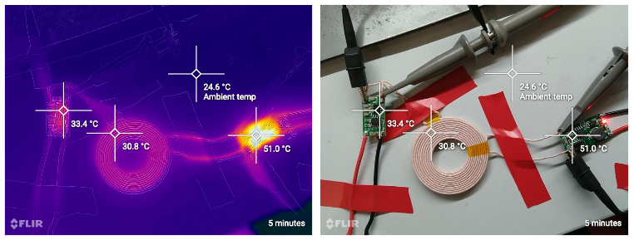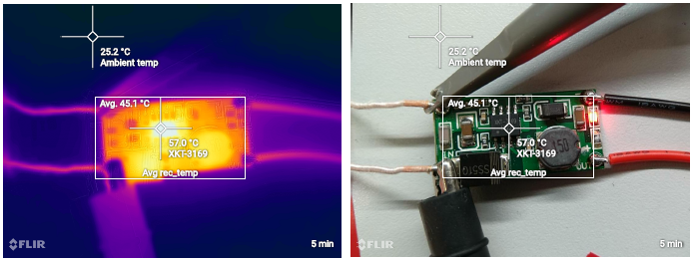

Primary controller secondary controller

Within two minutes the driver reaches a temperature of 45 degrees Celsius. After 5 minutes this temperature stabilizes until around 51-56 degrees Celsius. As you can see in figure X, this is the temperature when the setup is in an environment which can be approximated as open air. This indicates that the temperature will even rise further when the setup is in an enclosed environment (like in the body of patient simulator). On top of this, the charger has a poor efficiency, when there’s no load connected the wireless charging system still consumes 150mA. The bad efficiency is especially poor at the secondary side, this is mostly due to the switching losses caused by the buck converter.

From the graph below can be derived that the system doesn’t communicate through the Qi protocol, which in unfortunate, since there’s a lot of hardware available at an affordable price point for this protocol.

**INSERT ELNEOS SCOPE GRAPH**

**Conclusion**

To summarize the above:

* The wireless charging systems gets too hot, this will get worse in an enclosed environment.
* Poor efficiency which would lead to the need of a higher capacity battery.
* Not compatible with the Qi protocol
* Safety can’t be confirmed
* The charging coils are voluminous and rigid

Therefore we conclude that it is better to switch to a new wireless charging system. Preferably an off the shelf solution. For charging a standard wireless phone charger should be sufficient.

## 6.5 marketing context

In this chapter is going to be look at the marketing of the project. Therefore is written a marketing plan context where is described what is research and the goal. A couple of them are finding out how the infant life support simulation lay in the marked and who are the customers. Also there is research to continue the next sprint with researching marketing and marking it a full marketing plan. The possible to make a business plan is also looked into. Below is are the five competitive forces and there explanation.(Porter, Understanding michael Porter, 2012)(Porter, Competitive Advantage, 1985)

**The five competitive forces**

In this section we are analysing the meso environment of the Infant life support simulation. Therefore we use the five competitive forces from Porter. Two tools are going to be used the get a general idea of where the business stands. The tools contains multiple questions for each competitive force from very agreed to very not agreed. The two tools will be compared to see if the results look like each other. (mindtools, 2021)

* **Competitive Rivalry:** the strength and the number of competitors
* **Supplier Power:** how easy a supplier can increase its price
* **Buyer Power:** how easy customers can drive your price down
* **Threat of Substitution:** the likelihood that your customers find a different way of doing it
* **Threat of New Entry:** the ability for people to enter the market

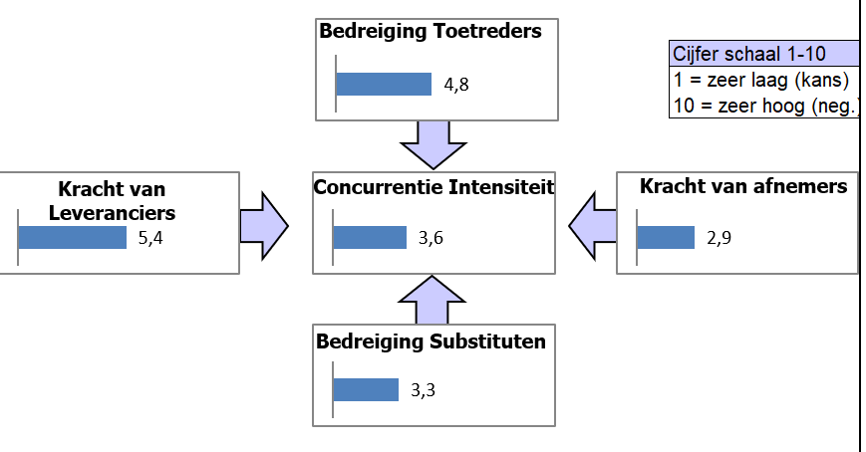Below you can see the five competitive forces address to the Infant life support simulation with scores. In the attachments you can find all the questions that where answered to give these scores.

Figure 1the fife competitive forces, Infant life support simulation

**conclusion**

Below you can see a filled in diagram of the five competitive forces.

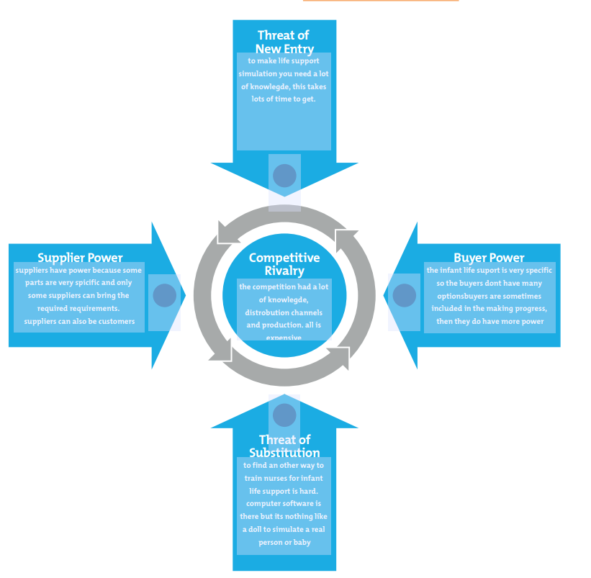

In the file, IEM-B-marketing analyse, you can find more information about this subject. In sprint 1 will be done the tasks of who are the customers and other parts of the marketing plan.

## 6.6 stakeholders

in this chapter there is being looked at the stakeholders of the Infant Life Support Simulation. By starting to identify all stakeholders for the project and of each faculty. After that the stakeholders will be categorized on intern, extern, interface, primary and secondary. the third part is prioritizing the stakeholders on influence and power. If that is clear, we determine the stakeholder’s approach by making tabulation. As last the relations between the stakeholders is showcased

The full file contains a more detailed explanation therefore refer to the document ‘stakeholders analyse’.

Below is going to be explained how the different stakeholders are approached, therefore are four option to do so. if that has done, they are placed in a tabulation to get the picture clear.

|  |  |  |  |  |  |  |  |
| --- | --- | --- | --- | --- | --- | --- | --- |
| ***INFLUENCE*** | **HIGH** |  | **KEEP**  **SATISFIED** | Vivian van Tilborg | | **MANAGE CLOSELY** | Johan Korten |
|  | Nanda Verheul | | All group members |
|  | Fieke en Johan | | HAN |
|  |  | Katja and Andries | |  |
|  |  | **MONITOR *(MINIMUM EFFORT)*** | Tino and Daniel | | **KEEP**  **INFORMED** | Nicolette Post |
| **LOW** | Tim and Theo | | Paul van Wegen |
|  | Customers | | Maarten |
|  |  |  | Radboud University | | suppliers |
|  |  |  | **LOW** | | | **HIGH** | |
|  |  |  |  | |  |  |  |
|  |  |  | ***INTEREST*** | | | | |
|  |  |  |  | | | | |

below is going to be a diagram of the relations between the stakeholders. There is given a score from one to five to each stakeholder. Five mean a lot, a lot of interest and 1 means little.

**Conclusion**

After the writing this analysis the following thinks are clear know.

1. Because the S6 project is aimed at working together, all group members are important stakeholders who are to manage closely.(manage closely)
2. Also its clear to see which stakeholders want to be updated with the progress and need to be invited to meetings.( keep informed)
3. Some stakeholders don’t want to be updated, they only want there demands to be met. ( keep satisfied)
4. The stakeholders who wants to be updated at the and of the project with the progress or are situational needed for council.(monitor)

# Bibliografie

mindtools. (2021, maartq 18). *Porter's Five Forces*. Opgehaald van mindtools: https://www.mindtools.com/pages/article/newTMC_08.htm

Porter, M. (1985). *Competitive Advantage.* New York: the free pres.

Porter, M. (2012). *Understanding michael Porter.* Boston: Joan Magretta.

# 10 rules and contract

In the Appendix 2 you can find the contact with rules the project group agreed to, also the contract is signed.

# Attachments

## Attachment 1

## Attachment 2

Volgende afspraken zijn van kracht gedurende de S6 project periode van Februari 2021 t/m juli 2021.

1. Wees op tijd. Kun je niet op de afgesproken tijd aanwezig zijn? Geef dit dan voor 00:00 aan in de project Whatsapp-groep de dag voor de meeting.

Heb je niet tijdig aangegeven dat je er niet op tijd kan zijn? Dan heeft dit de volgende consequenties als je 5+ minuten te laat bent:

1. a. Traktatie
   1. b. Milde waarschuwing (een streepje op je naam)
   2. 2. Je moet je werk af hebben voor de afgesproken deadlines. Heb je je werk niet af op of voor de afgesproken deadline heeft dat de volgende consequentie: a. Officiële waarschuwing (twee streepjes op je naam)
   3. 3. Toon voldoende inzet gedurende het hele project. Dit is moeilijk meetbaar, aan de volgende punten zal aandacht besteed worden om dit te controleren:
      1. a. Aanwezigheid bij meetings en je participatie gedurende de meetings (dus ook je inbreng).

b. Reactie op berichten/oproepen in de Whatsapp-groep, op e-mails, of op Teams en discord etc.

* + 1. c. Actief bezig met de scrummethode en het stellen van doelen voor de sprintjes.
  1. d. Voldoen aan de deadlines.

4. Elke *online* werkdag om 09:00 stand-up meeting. In deze meeting wordt de voortgang gemeten en worden afspraken gemaakt over de planning.

* 1. 5. Er wordt verwacht dat je elke woensdag, donderdag en vrijdag gedurende de projectperiode beschikbaar bent van 9:00-17:00 om aan het project te werken. Mocht je andere activiteiten hebben gedurende deze tijden, laat dan het volgende weten in de stand-up meeting:
     1. a. Gedurende welk tijdsbestek je afwezig bent.
  2. b. Of je bereikbaar bent gedurende je afwezigheid.
     + 1. c. Of het projectafspraken in de weg zit. Zo ja, wat ga je er dan aan doen zodat dit niet het geval is.

6. Elke week (minstens) eenmaal fysiek afspreken op de HAN Arnhem. Bij voorkeur elke woensdag, hier kan van afgeweken worden als er andere afspraken gemaakt worden (bv. door COVID-19 of workshops etc). Bij een *fysieke* werkdag *op school* start de stand-up om 9:15.

De consequenties van een streepje op je naam zijn n.t.b. en worden opgenomen in de aanwezigheid lijst. Ik ga akkoord met de bovengenoemde afspraken:

Voor- en Achternaam: ………………………………………………………..

Datum en handtekening :……………………………………………………..

## Attachment 3

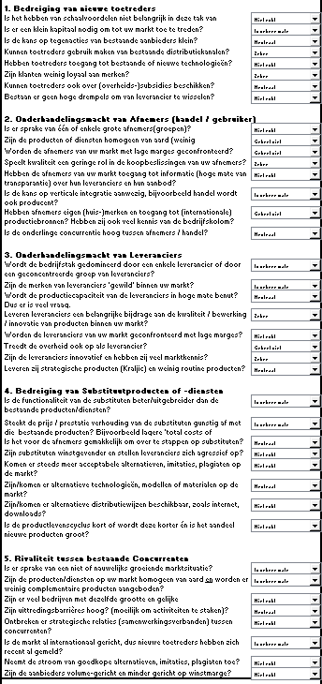

# Bibliografie

mindtools. (2021, maartq 18). *Porter's Five Forces*. Opgehaald van mindtools: https://www.mindtools.com/pages/article/newTMC_08.htm

Porter, M. (1985). *Competitive Advantage.* New York: the free pres.

Porter, M. (2012). *Understanding michael Porter.* Boston: Joan Magretta.